About Us Pages

* For the remaining 12 d3h hotel websites on the “About Us” page we need to make the same update
  + Remove completely this image thumbnail in the “Our Hotels” section of each About Us Page 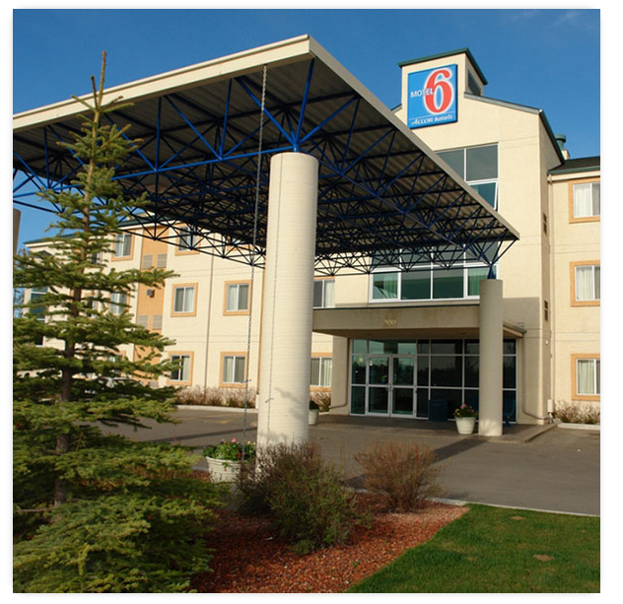
  + Then update the static text that currently reads:

Days Inn Calgary North Balzac is managed by d3h Hotels Inc. This executive hotel management company owns and operates 14 hotels across Western Canada. d3h operates under four major franchise brands: Home Hotels, Days Inn and Motel 6. The management company is Realstar Hospitality’s largest franchisee, owning and operating the following properties:

To the text as outlined below on each page

<http://www.daysinncalgarynorthbalzac.ca/about-us>

Days Inn Calgary North Balzac is managed by d3h Hotels Inc. This executive hotel management company owns and operates 13 hotels across Western Canada. d3h operates under two major franchise brands: Home Hotels & Days Inn. The management company is Realstar Hospitality’s largest franchisee, owning and operating the following properties:

<http://www.homeinnexpressmh.ca/about-us>

Home Inn Express Medicine Hat is managed by d3h Hotels Inc. This executive hotel management company owns and operates 13 hotels across Western Canada. d3h operates under two major franchise brands: Home Hotels & Days Inn. The management company is Realstar Hospitality’s largest franchisee, owning and operating the following properties:

<http://www.homesuites.ca/about-us>

HomeSuites Regina is managed by d3h Hotels Inc. This executive hotel management company owns and operates 13 hotels across Western Canada. d3h operates under two major franchise brands: Home Hotels & Days Inn. The management company is Realstar Hospitality’s largest franchisee, owning and operating the following properties:

<http://www.homeinnreginaairport.ca/about-our-regina-airport-hotel>

Home Inn & Suites Regina Airport is managed by d3h Hotels Inc. This executive hotel management company owns and operates 13 hotels across Western Canada. d3h operates under two major franchise brands: Home Hotels & Days Inn. The management company is Realstar Hospitality’s largest franchisee, owning and operating the following properties:

<http://www.homeinnsaskatoonsouth.ca/about-our-saskatoon-hotel>

Home Inn & Suites Saskatoon South is managed by d3h Hotels Inc. This executive hotel management company owns and operates 13 hotels across Western Canada. d3h operates under two major franchise brands: Home Hotels & Days Inn. The management company is Realstar Hospitality’s largest franchisee, owning and operating the following properties:

<http://www.homeinnyorkton.ca/about-our-yorkton-hotel>

Home Inn & Suites Yorkton is managed by d3h Hotels Inc. This executive hotel management company owns and operates 13 hotels across Western Canada. d3h operates under two major franchise brands: Home Hotels & Days Inn. The management company is Realstar Hospitality’s largest franchisee, owning and operating the following properties:

<http://www.homeinnswiftcurrent.ca/about-us>

Home Inn & Suites Swift Current is managed by d3h Hotels Inc. This executive hotel management company owns and operates 13 hotels across Western Canada. d3h operates under two major franchise brands: Home Hotels & Days Inn. The management company is Realstar Hospitality’s largest franchisee, owning and operating the following properties:

<http://www.daysinnmedicinehat.ca/about-our-medicine-hat-hotel>

Days Inn Medicine Hat is managed by d3h Hotels Inc. This executive hotel management company owns and operates 13 hotels across Western Canada. d3h operates under two major franchise brands: Home Hotels & Days Inn. The management company is Realstar Hospitality’s largest franchisee, owning and operating the following properties:

<http://www.daysinnreddeer.ca/about-us>

Days Inn Red Deer is managed by d3h Hotels Inc. This executive hotel management company owns and operates 13 hotels across Western Canada. d3h operates under two major franchise brands: Home Hotels & Days Inn. The management company is Realstar Hospitality’s largest franchisee, owning and operating the following properties:

http://www.daysinnregina.ca/about-us

Days Inn Regina is managed by d3h Hotels Inc. This executive hotel management company owns and operates 13 hotels across Western Canada. d3h operates under two major franchise brands: Home Hotels & Days Inn. The management company is Realstar Hospitality’s largest franchisee, owning and operating the following properties:

<http://www.daysinnedmontonsouth.ca/about-us>

Days Inn Edmonton South is managed by d3h Hotels Inc. This executive hotel management company owns and operates 13 hotels across Western Canada. d3h operates under two major franchise brands: Home Hotels & Days Inn. The management company is Realstar Hospitality’s largest franchisee, owning and operating the following properties:

<http://www.daysinnreginaairportwest.ca/about-our-regina-hotel>

Days Inn Regina Airport West is managed by d3h Hotels Inc. This executive hotel management company owns and operates 13 hotels across Western Canada. d3h operates under two major franchise brands: Home Hotels & Days Inn. The management company is Realstar Hospitality’s largest franchisee, owning and operating the following properties: